

**CSE251**

**Electronic Devices and Circuits**

Exp -01: Study of Diode Characteristics

**Submitted By**

Name: Shihab Muhtasim

ID: 21301610

Group: 05

Semester: Fall 22

**Cooperated by**

ID: 21301611

ID: 20101443

ID: 20201066

Date of performance: 03/10/22

Date of Submission: 09/10/22

**2. Circuit Diagram:**

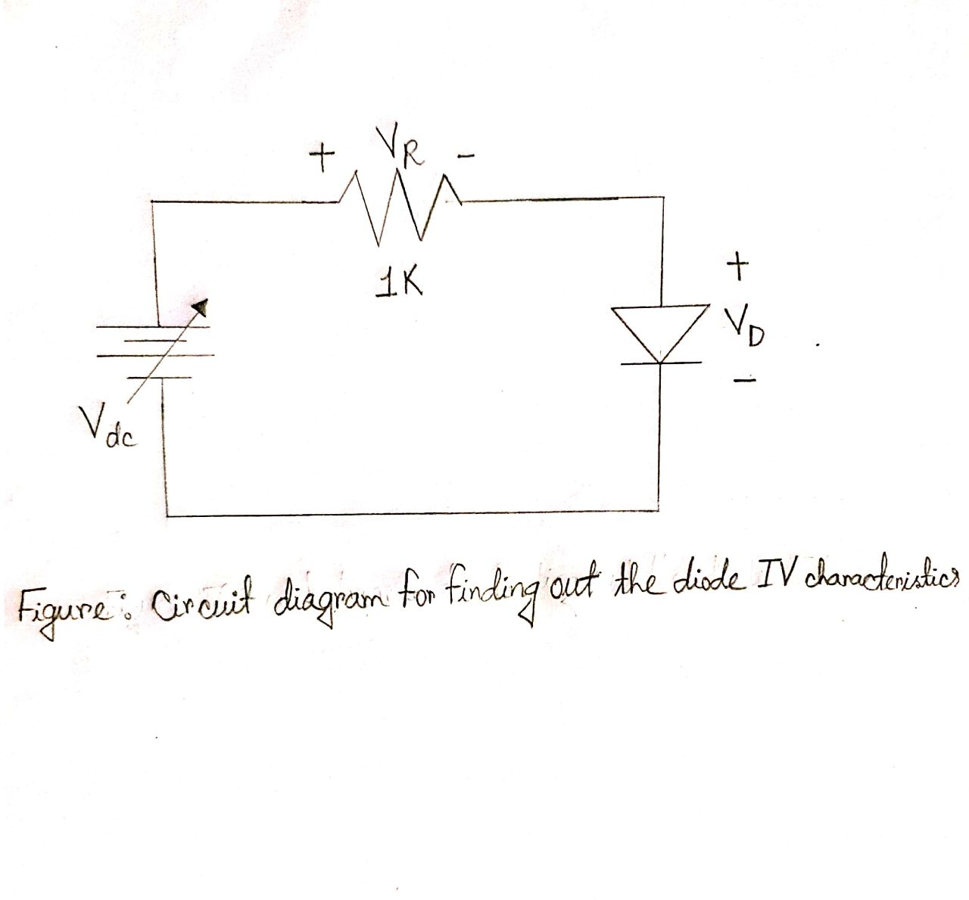

**3. Signed Data Sheet:**

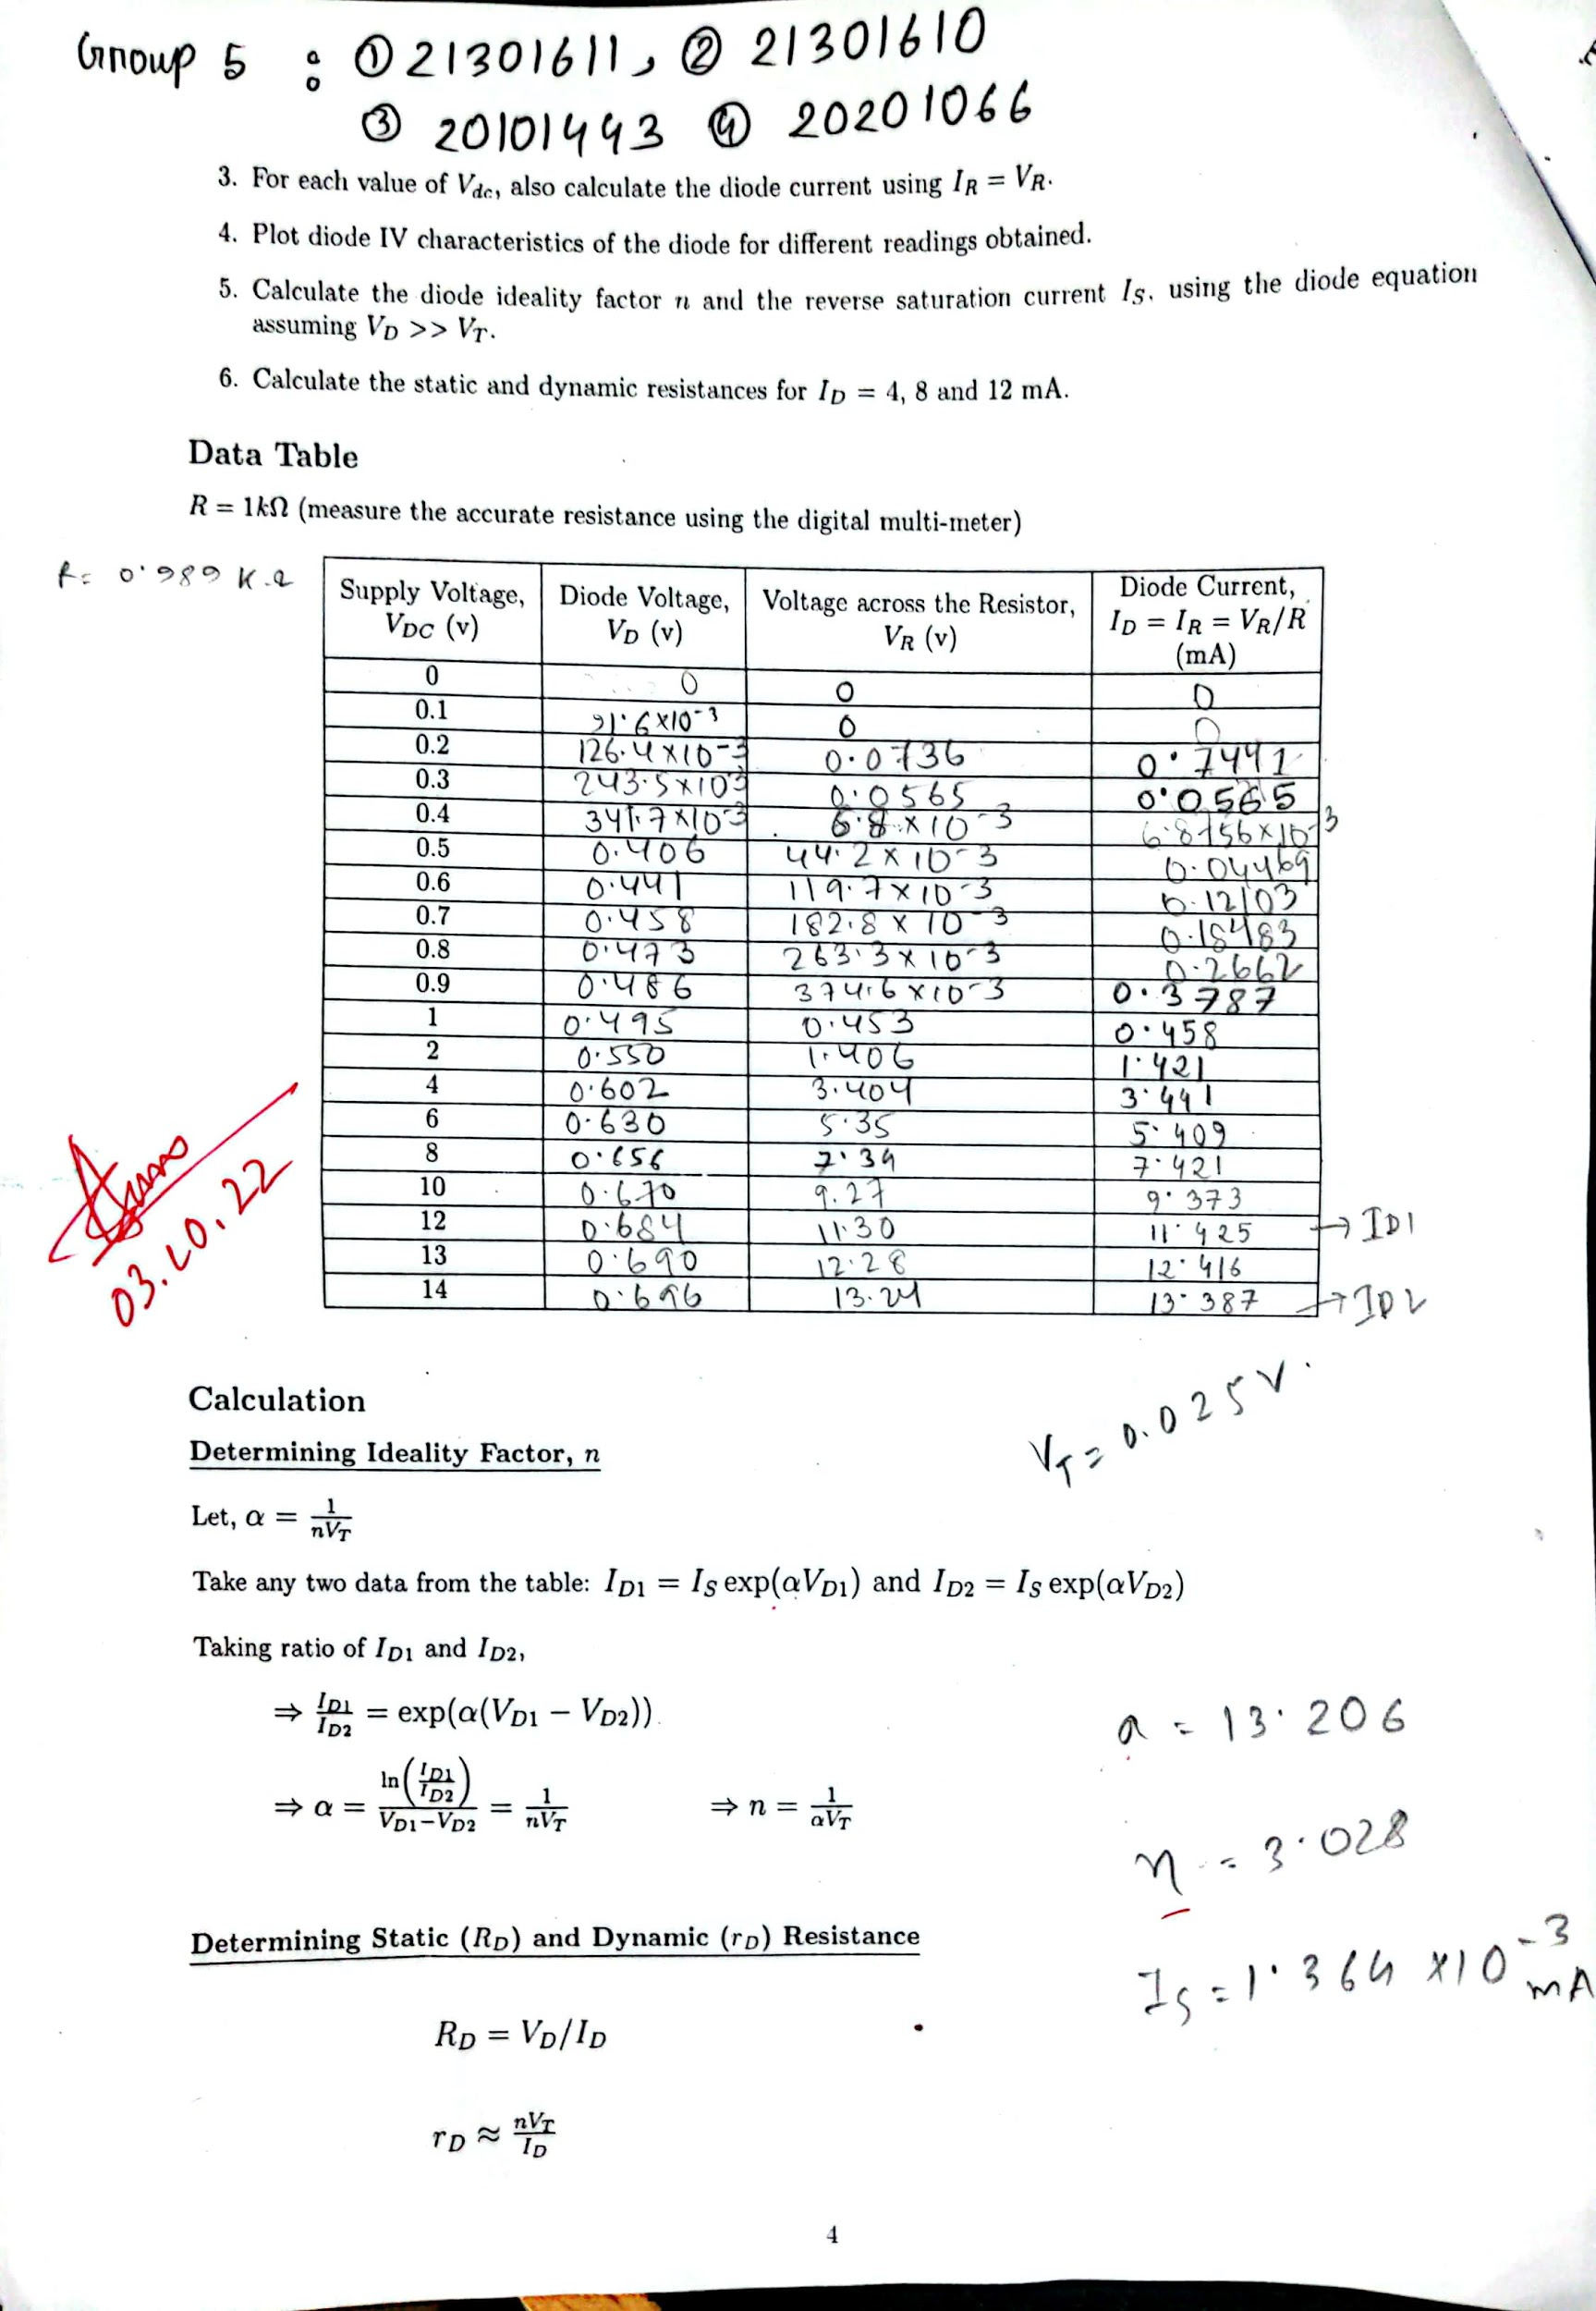

**Calculations:**

By letting, ID1= 11.425 , ID2 = 13.387

We get, VD1= 0.684, VD2= 0.696

Value of α:

α= ln(ID1/ID2)/(VD1-VD2)

=ln(11.425/13.387)/(0.684- 0.696)

= 13.206

Value of n:

n=1/α*VT

= 1/(13.206 * 0.025)

= 3.028

Value of Is:

Is = ID1/exp(α*VD1)

= 11.425/exp(13.206*0.684)

= 1.364*10^{-3} mA

**4. Graph From Task 2 and Calculated Parameters from graph:**

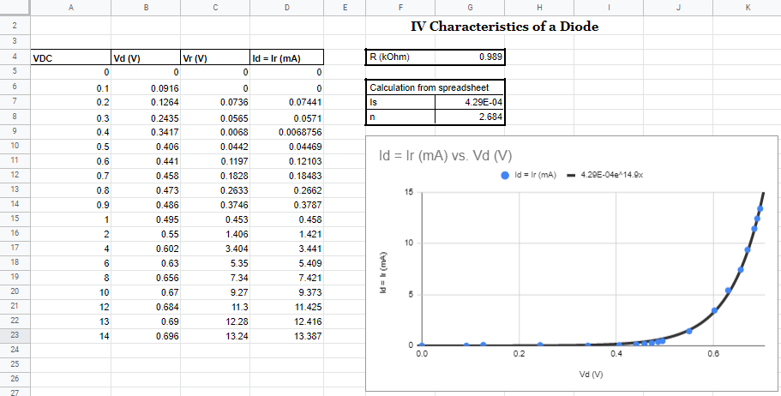

**5. Simulated Circuit in Lt spice:**

Here, The last two digits of my student id are 1 and 0

Hence, R= [2+ (10/10)]= 3k ohm

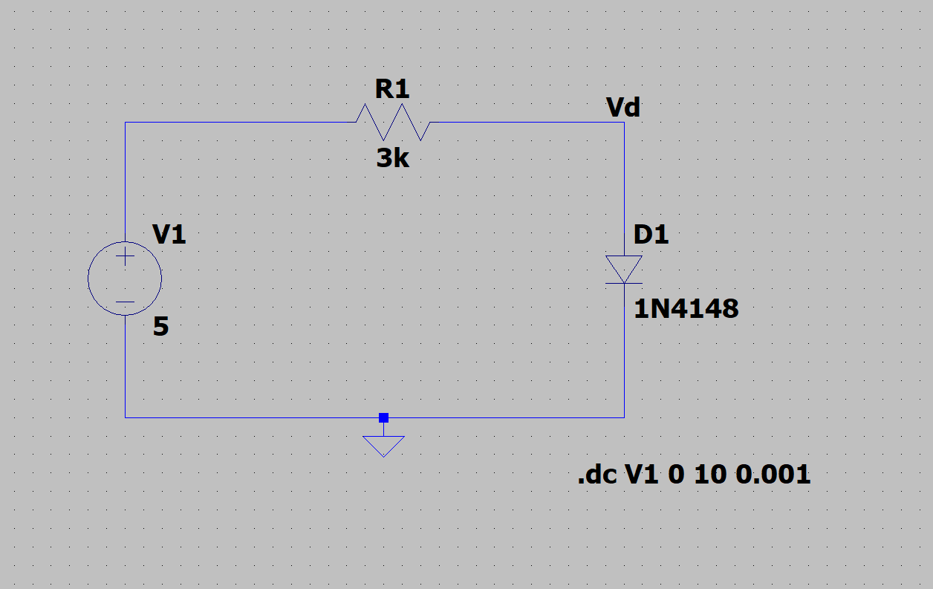

**IV Graph from the circuit:**

(ID Vs VD)

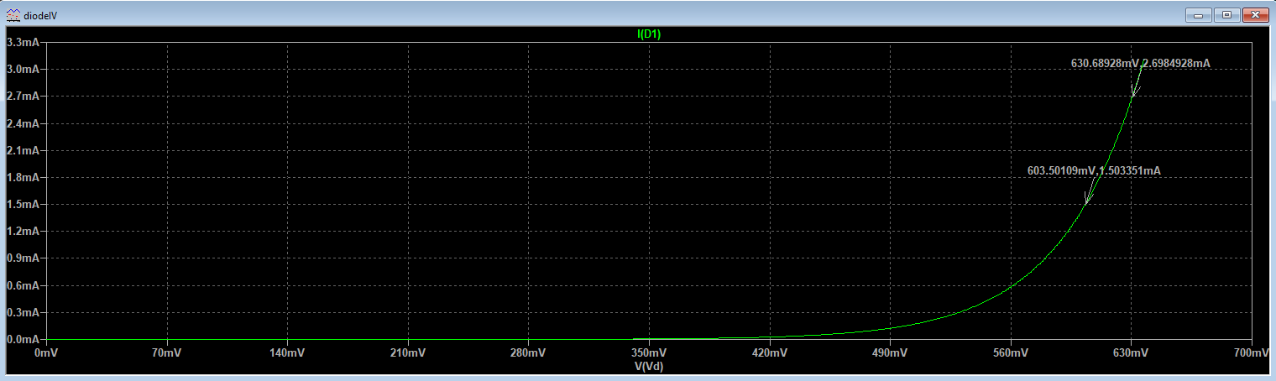

**Differences in Graphs of Task 2 and Task 3:**

By comparing the graphs we can see that this graph and the one generated in task 2 are similar and have the same shape even though they have different resistance which leads us to conclude that, the diode’s nature doesn’t depend on the resistance connected to it.

However, if we try to analyze closely we can see that the plot in LT spice shows different values of current ID for horizontally active voltage Vd than the graph in task 2. For instance, in the hardware lab, we obtained ID = 5.409 mA for VD = 630 mV whereas in LT spice we get ID = 2.67 mA current for VD = 630.30 mV which is a different value than the hardware lab’s value. If we analyze the data sets for all other voltages we will face differences in values for all of those. Two reasons can be inferred for this to happen.

Firstly, because the current Id of the circuit depends on the resistance and we have used a different resistance in LT spice which occurs in different datasets.

Secondly, hardware lab datasets don’t give accurate results as there are usually small errors from the hardware, and also these are manmade operations that altogether don’t give the perfect results.

Nevertheless, the datasets for both graphs being different they both provide similar exponential graph curves which proves that the diode follows its nature in both cases.

**5. DISCUSSION**

1. We could understand all the tasks of this experiment and get the expected results from our hardware along with software operations. We could measure Vd and Vr using a voltmeter. Then we were able to find the current through diode Id by dividing the voltages across resistors for each dataset by the resistance value of our circuit. Furthermore, we calculated the values for Is, n, and alfa for these datasets manually using the equations.
2. We were able to draw an Id vs Vd graph for the hardware datasets in a spreadsheet and generated an equation that gave us more accurate results for Is and n than our manual calculations.
3. We know that the value of the diode ideality factor (n) is between 1 and 2. However, in the hardware lab, with manual calculations in task 1, we obtained n = 3.028 for our circuit which is outside its general parameters. Nevertheless, when we used the same values in a spreadsheet while doing task 2 to generate a graph, we obtained a more efficient value for n from the equation auto-generated by the graph. There we could see that the value of n was 2.684 which is much closer to the given parameters. The extra 0.684 can be considered as an error from our hardware operations since all the datasets were manmade manual calculations which usually don’t provide theoretically perfect results. Hence, we can conclude that when we were calculating the values for Is and n manually, we had to use two equations and we could only work with two different datasets (eg. Id1, Vd1, and Id2, Vd2) for which we received less accurate values for Is and n. However, the spreadsheet automatically generated one equation comparing all of our data sets from the graph which gave us more accurate results of Is and n.
4. We successfully implemented the circuit in LT spice and generated an Id vs Vd graph from that circuit. However, we used a different resistance value in that circuit yet the graph generated was the same as the one generated from the spreadsheet. This leads us to prove that, the nature of the diode doesn’t depend on the resistor connected to it. No matter what the value of the resistor is, the diode will act according to Its nature which is, in this case, to behave as a short circuit after a minimal amount of voltage has been applied where the voltage becomes 0.